**DAILY ONLINE ACTIVITIES SUMMARY**

|  |  |  |  |  |  |  |  |  |
| --- | --- | --- | --- | --- | --- | --- | --- | --- |
| **Date:** | **16/06/2019** | | | | | **Name:** | **Varshitha Makam** | |
| **Sem & Sec** | **8th B** | | | | | **USN:** | **4AL16CS118** | |
| **Online Test Summary** | | | | | | | | |
| **Subject** | | **BDA** | | | | | | |
| **Max. Marks** | | **30** | | **Score** | | | **14** | |
| **Certification Course Summary** | | | | | | | | |
| **Course** | **Introduction To Hadoop** | | | | | | | |
| **Certificate Provider** | | | **GreatLearning** | | **Duration** | | | **4 hours** |
| **Coding Challenges** | | | | | | | | |
| **Problem Statement:** | | | | | | | | |
| **Status: Completed** | | | | | | | | |
| **Uploaded the report in Github** | | | | | **yes** | | | |
| **If yes Repository name** | | | | | **Varshithamakam**  **https://github.com/alvas-education-foundation/varshithamakam** | | | |
| **Uploaded the report in slack** | | | | | **yes** | | | |

Online Test Details:

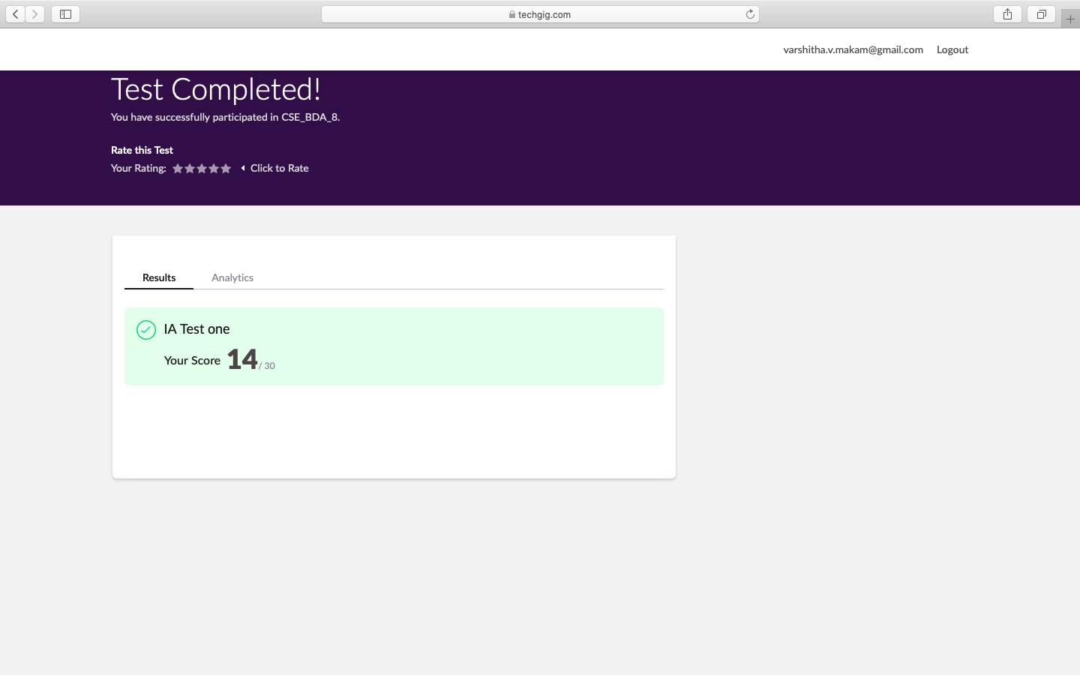

Certification Course Details:

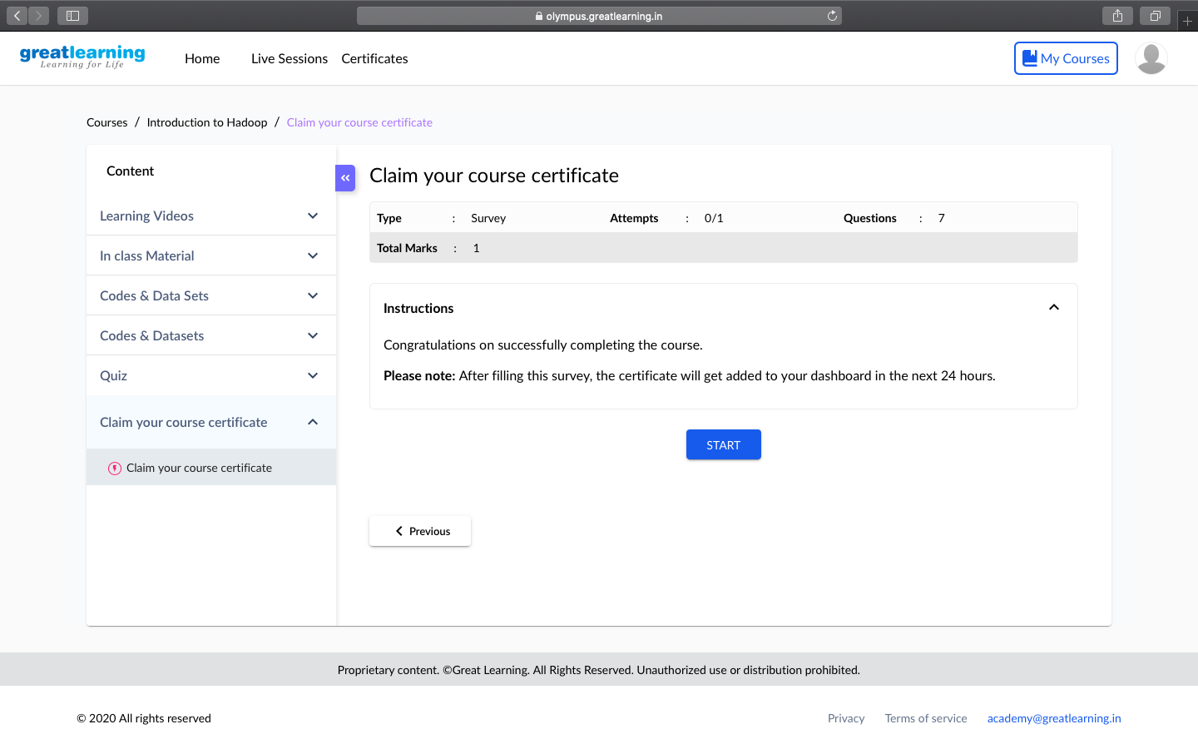

Coding Challenges Details:

#include <stdio.h>

int check_armstrong(int);

int power(int, int);

int main ()

{

int c, a, b;

printf("Input two integers\n");

scanf("%d%d", &a, &b);

for (c = a; c <= b; c++)

if (check_armstrong(c) == 1)

printf("%d\n", c);

return 0;

}

int check_armstrong(int n) {

long long sum = 0, t;

int remainder, digits = 0;

t = n;

while (t != 0) {

digits++;

t = t/10;

}

t = n;

while (t != 0) {

remainder = t%10;

sum = sum + power(remainder, digits);

t = t/10;

}

if (n == sum)

return 1;

else

return 0;

}

int power(int n, int r) {

int c, p = 1;

for (c = 1; c <= r; c++)

p = p*n;

return p;

}